Varun Khadayate

Dr. Arvind Mathur

BTech CSBS

13-08-2020

The Kashmir Issue: The Conflict Explained

The dispute between India and Pakistan over Kashmir is one among the longest-running conflicts. India and Pakistan’s first war were fought over Kashmir’s status because the newly independent countries were being formed. After over a year of bloody conflict, the UN stepped in and brokered a ceasefire that drew a line down the center of Kashmir and gave some of the territory to India and therefore the remainder to Pakistan. Once the violence settled a vote was to be held that might allow Kashmiris to make a decision their future. But quite 70 years later, Kashmiris have yet to vote on their status. they continue to be stuck between two nuclear nations locked during a dangerous conflict with without stopping in view.

On Valentine Day, 2019, a terrorist attacked a convoy of Indian security forces. He killed a minimum of 14 Indian soldiers here in Kashmir “We are getting reports of multiple casualties in a roadside. The deadliest attack the region has seen this century” [Ref the Quint]. The bomber was a part of an Islamic militant group based in Pakistan. “Jaish-e-Mohammad claimed responsibility for that attack.” [Ref the Quint]. 12 Days later India administered airstrikes in Northwestern Pakistan. Then Pakistan shot down a minimum of one Indian aircraft around Pulwama. the strain rose between the two rival nations “The most serious escalation in years” [Ref the Quint]. Kashmir is one among the foremost disputed places on the world. Over 70 years, it’s been at the middle of three wars fought between 2 massive armies. It's heavily occupied by quite half 1,000,000 Indian troops and a deadly collection of militias and terrorist groups. Kashmir is that the stage for the relentless conflict between India and Pakistan. But that specialize in the two countries can obscure what's at stake: The voice of Kashmiris who are caught during this vicious circle of violence.

Whenever there is any conflict between India and Pakistan, Kashmir is the only place which is always a battleground. Kashmir is a disputed area. It neither belongs to India- nor Pakistan. Two giant – nuclear giants, were noted in between them. There is always uncertainty, you know you never know what is going to happen. It can be a hartal. It can be a strike. Anybody can be killed anytime. They are the pawns in their hands. It’s a mess. It is a mess and the people are affected in every possible direct and indirect way People will be born in this conflict and will also die in it.

Kashmir is one of the foremost strategic places in the world, where 3 powerful countries collide namely India, Pakistan, and China. China invaded into the ASKAI CHIN slice of Kashmir from India and Pakistan into the SHAKSGAM VALLEY. Refer Fig. 1

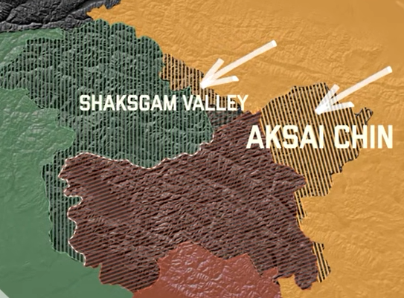

Fig. 1

India and Pakistan controlled these parts, but lay came to more.

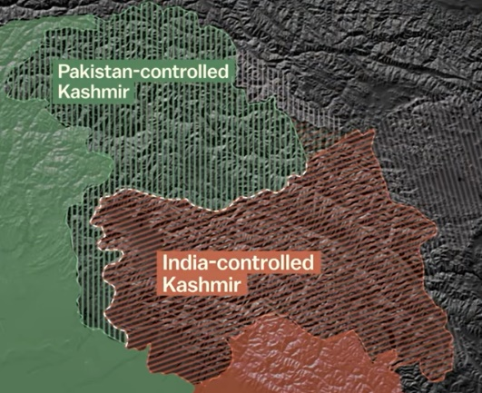

Fig. 2

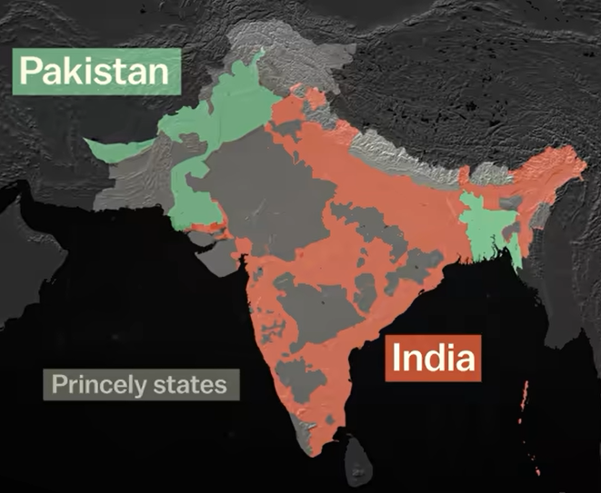This region is at the middle of a brutal conflict over these disputed borders. [Ref Fig. 2] So it is vital to start out once they were been drawn. within the mid-1800s, India was a patchwork of several hundred provinces and princely states under British rule. A century later, when British India won Independence, British left and hastily plan to split the region into two. These areas would be a replacement Muslim-majority country, Pakistan, and another the mostly Hindu, but secular, India [Ref Fig. 3]

Fig. 3

Fig. 3

The Partition was bloody. “Communal hatred flares up in Punjab 1 million people became refugees overnight. They flee from savagery and butchery that has never been exceeded, even in India’s stormy history.” [Ref BBC Timeline]. Amid the chaos, some princely states got the selection to hitch either country. In most cases, the riling Monarch followed the desire of their people. But, the state of ‘Jammu and Kashmir’ was different. it had been all along this border and had a Muslim-majority population, but was ruled by Hindu Monarch. When asked to select a side, the ruler chose to remain neutral. Fearing at the Monarch would join India, the Kashmiri population rebelled in POONCH in 1947. Armed tribesmen from Pakistan soon joined in the fight. The monarch turned to India for military help and in exchange agreed to hitch them, which sparked the primary Indo-Pakistan was in Kashmir. “Continuing thus increased the threat to world peace and brought the dispute to the attention of UN” [Ref BBC Timeline]. The UN Security Council Broke a ceasefire in 1949, which establishes a line between India and Pakistan in Kashmir. It also asked Pakistani tribesman to withdraw and Indian troops to follow, in order that Kashmir could hold an immediate vote to make a decision its future. But neither delayed that end of the deal.

Pakistan argued that the Kashmir’s Muslim-majority population rightfully belonged to them. While India Insisted that Kashmir was handed over to them by Hindu monarch. So, they doubled down the power and had added Kashmir to their constitution.

THE VOTE WAS NEVER HELD.

I think every person in Kashmir has been affected by India and Pakistan. The Kashmir is destroyed by India, as well as, Pakistan. This is the so-called TERRITORIAL DISPUTE; they don’t need people. The main stakeholders are Kashmiris, their opinions are not being heard.

Both countries continued to tighten up their grip around it for decades. “Kashmir. Fighting is going on and heavy casualties in men and equipment have been inflicted on the aggressor.” [Ref BBC Timeline].

In 1965, the second Indo-Pakistan war broke call at Kashmir. Thousands of individuals were killed between the large armies on each side. A ceasefire ended the war but didn’t change the road. Kashmir was kept divided and occupied. And another war broke call at 1971. this point the main target wasn’t in Kashmir – it had been in Bangladesh [Refer Fig. 4]

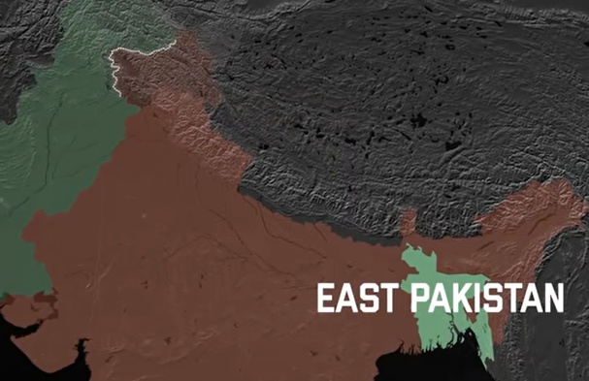

Fig. 4

This region became a new country, Bangladesh and Pakistan had lost its eastern half. [Ref Fig. 5]

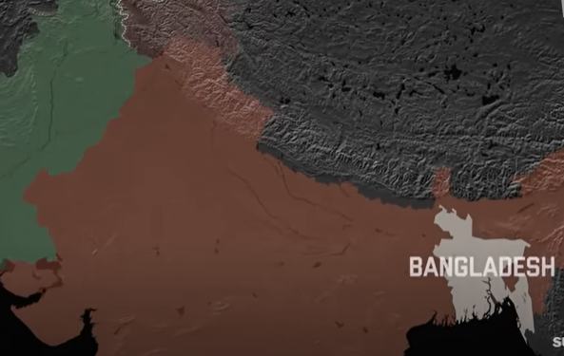

Fig. 5

This made Kashmir more important than ever. It became one among the foremost militarized places on Earth, as India and Pakistan deployed planes, tanks, artillery, and soldiers along the LOC.

On the political front, in 1987, India reportedly rigged an election, declaring a pro-India party because the winner. Now, this was the large turning point for several Kashmiris, who felt they were again denied the prospect to vote. Thousands took to the streets in India-controlled Kashmir to protest the occupation.

“In January security forces opened fire on demonstrating separatists, turning a two-year-old struggling movement into a full-blown popular uprising. More than 600 people have been killed in clashes between troops and separatists.” [Ref Freedom House Report]

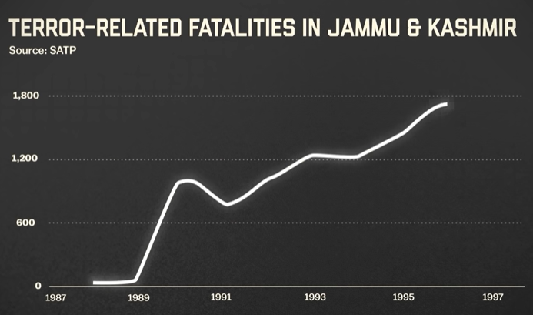Kashmiri militias, a bit like the Jammu and Kashmir Liberation Front, started recruiting Muslim youth to fight for independence and increasingly attacked the Indian Military. [Ref Fig. 6]

Fig. 6

Pakistan saw a chance during this insurgency. They helped introduce a replacement quite militant group: Radical Islamic fighters who fought for more pro-Pakistan Kashmir. By the mid-1990s, these groups dominated the insurgency. India responded with the incredible military unit, deploying 5,00,000 troops to Kashmir and that they cracked down on militants and protesters. Unarmed civilians were killed and lots of more were forced to escape the violence. And in 1998 the stakes were raised once more. Kashmir became a battleground between two nuclear-armed nations and another war broke call at 1999. The 1999 war ended with another ceasefire, but that didn’t stop either of the countries. Over the years, Pakistan’s militant groups got bolder and launched terror attacks in and out of doors Kashmir.

The Indian Army’s crackdown drives some Kashmiris to hitch Pakistani-backed militant groups, who perform violence against the Indian forces. It’s a cycle that Kashmiri civilians are stuck within the middle of.

Which bring us back to 2019, the terrorist was 19-year old Adil Ahmed Dar from Pulwama, Kashmir. consistent with its parents in 2016, India cops stopped him and humiliated him by forcing his face into the bottom. an equivalent year he was shot within the leg at a protest. subsequent year, Dar left home together with his brothers, to hitch Jaish-e-Mohammed, a Pakistani-supported militia that radicalized him and trained him to be a terrorist. A year later, he drove explosives onto an Indian Military Convoy.

For quite 70 years India and Pakistan have driven a cycle of violence, retaliation, and exploitation in Kashmir. But beneath it, all is that the Kashmiri’s wish to form a choice. A wish that continues to get suppressed again and again by the violence.

**Bibliography**

1. BBC Timeline: <https://www.bbc.com/news/world-south-asia-16069078>
2. UN report — Human Rights in Kashmir: <https://www.ohchr.org/Documents/Countries/IN/DevelopmentsInKashmirJune2016ToApril2018.pdf>
3. CFR Conflict Tracker: <https://www.cfr.org/global-conflict-tracker/conflict/conflict-between-india-and-pakistan>
4. Freedom House Report: <https://freedomhouse.org/report/freedom-world/2018/indian-kashmir>
5. The Quint: <https://www.thequint.com/news/politics/kashmir-narendra-modi-farooq-abdullah-omar-amit-shah-bjp-nc>